DBMS ASSIGNMENT
WEEK – 6
1)Group_By Clause

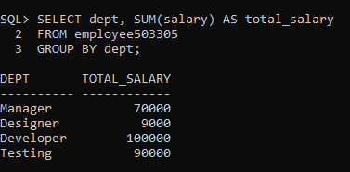

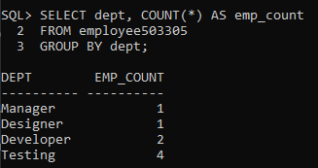

2)Subqueries

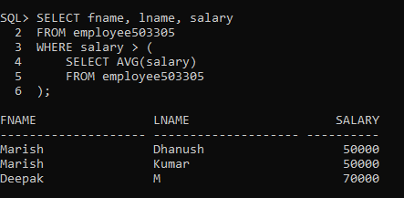

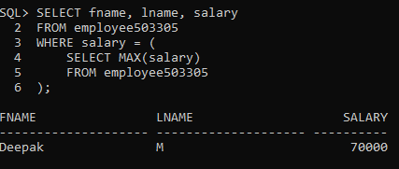

3)Joins
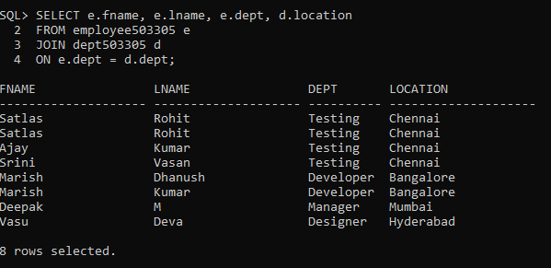

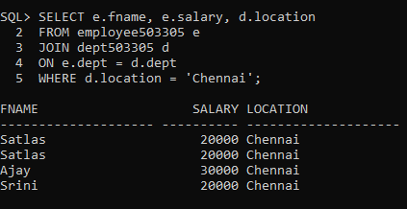

4)Join Insert

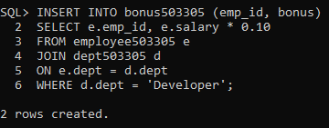

5)Join Update

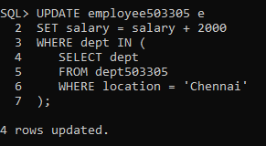

6)Join Delete

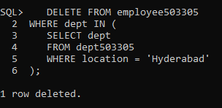

PL/SQL
Anomaly3305.sql
DECLARE
v_salary employee503305.salary%TYPE;
BEGIN
DBMS_OUTPUT.PUT_LINE('Satlas – 2024503305');
SELECT salary INTO v_salary
FROM employee503305
WHERE emp_id = 1;
DBMS_OUTPUT.PUT_LINE('Salary = ' || v_salary);
END;
/

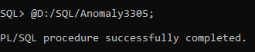
Output:

Procedure3305.sql
CREATE OR REPLACE PROCEDURE get_emp_salary503305(p_id NUMBER)
IS
v_salary employee503305.salary%TYPE;
BEGIN
DBMS_OUTPUT.PUT_LINE('Satlas – 2024503305');
SELECT salary INTO v_salary
FROM employee503305
WHERE emp_id = p_id;
DBMS_OUTPUT.PUT_LINE('Salary = ' || v_salary);
END;
/
EXEC get_emp_salary503305(3);

Output:
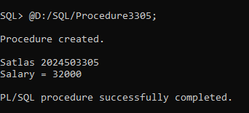

Cursor3305.sql
DECLARE
CURSOR emp_cursor IS
SELECT fname, salary FROM employee503305;
v_name employee503305.fname%TYPE;
v_salary employee503305.salary%TYPE;
BEGIN
DBMS_OUTPUT.PUT_LINE('Satlas – 2024503305');
OPEN emp_cursor;
DBMS_OUTPUT.PUT_LINE('Name' || ' ' || 'Salary');
LOOP
FETCH emp_cursor INTO v_name, v_salary;
EXIT WHEN emp_cursor%NOTFOUND;
DBMS_OUTPUT.PUT_LINE(v_name || ' → ' || v_salary);
END LOOP;
CLOSE emp_cursor;
END;
/
Output:
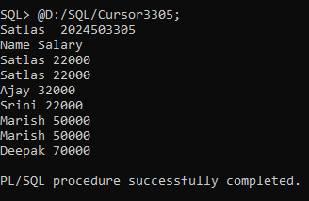

Insert_Trig3305.sql
CREATE OR REPLACE TRIGGER trg_insert503305
BEFORE INSERT ON employee503305
FOR EACH ROW
BEGIN
DBMS_OUTPUT.PUT_LINE('Satlas – 2024503305');
DBMS_OUTPUT.PUT_LINE('New employee inserted');
END;
/
Output:

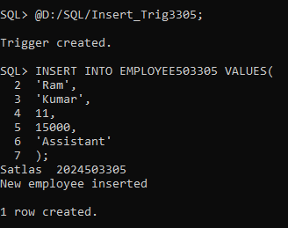

Update_Trig3305.sql
CREATE OR REPLACE TRIGGER trg_update503305
BEFORE UPDATE ON employee503305
FOR EACH ROW
BEGIN
DBMS_OUTPUT.PUT_LINE('Satlas 2024503305');
DBMS_OUTPUT.PUT_LINE('Salary updated');
END;
/
Output:
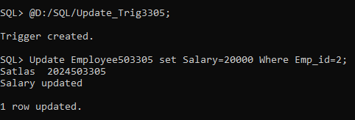

Delete_Trig3305.sql
CREATE OR REPLACE TRIGGER trg_delete503305
BEFORE DELETE ON employee503305
FOR EACH ROW
BEGIN
DBMS_OUTPUT.PUT_LINE('Satlas 2024503305');
DBMS_OUTPUT.PUT_LINE('Employee deleted');
END;
/
Output:
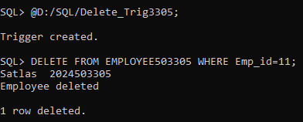

IF_Statement3305.sql
DECLARE
v_salary NUMBER := 30000;
BEGIN
DBMS_OUTPUT.PUT_LINE('Satlas 2024503305');

IF v_salary > 25000 THEN
DBMS_OUTPUT.PUT_LINE('High Salary');
ELSE
DBMS_OUTPUT.PUT_LINE('Low Salary');
END IF;
END;
/
Output:
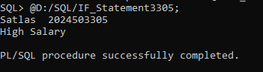

LOOP_Statement3305.sql;
DECLARE
i NUMBER := 1;
BEGIN
DBMS_OUTPUT.PUT_LINE('Satlas 2024503305');

LOOP
DBMS_OUTPUT.PUT_LINE('Value: ' || i);
i := i + 1;
EXIT WHEN i > 5;
END LOOP;
END;
/

Output:
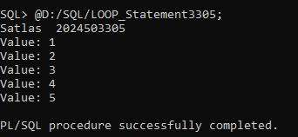

WHILE_Statement3305.sql
DECLARE
i NUMBER := 1;
BEGIN
DBMS_OUTPUT.PUT_LINE('Satlas 2024503305');

WHILE i <= 5 LOOP
DBMS_OUTPUT.PUT_LINE('Value: ' || i);
i := i + 1;
END LOOP;
END;
/
Output:
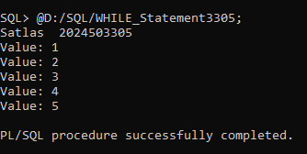

FOR_Statement3305.sql
BEGIN
DBMS_OUTPUT.PUT_LINE('Satlas 2024503305');

FOR i IN 1..5 LOOP
DBMS_OUTPUT.PUT_LINE('Value: ' || i);
END LOOP;
END;
/

Output:
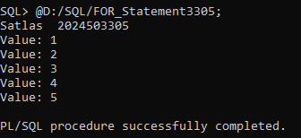

CASE_Statement3305.sql
DECLARE
v_dept VARCHAR2(20) := 'Manager';
BEGIN
DBMS_OUTPUT.PUT_LINE('Satlas 2024503305');

CASE v_dept
WHEN 'Manager' THEN DBMS_OUTPUT.PUT_LINE('Manager Dept');
WHEN 'Developer' THEN DBMS_OUTPUT.PUT_LINE('Developer Dept');
ELSE DBMS_OUTPUT.PUT_LINE('Other Dept');
END CASE;
END;
/
Output:
